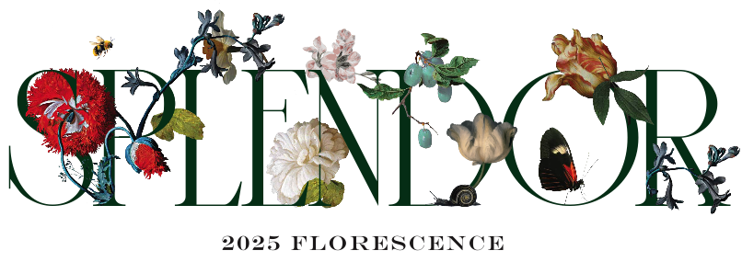

Class Entry Fee Form

If the class that you have entered has an entry fee like in Horticulture or Botanical Arts. You can simply pay that fee through the PayPal link located on your account page. Be sure to specify in the description area what the fee is for.

Or you can mail a check made out to Florescence (along with this form) to:

Meg Tapp

3736 Tangley Rd.

Houston, Texas 77005

Name:

Phone:

Class:

Amount: